CENTRAL BOARD OF SECONDARY EDUCATION · CLASS X

SHARDA INTERNATIONAL SCHOOL

PRACTICAL FILE
Information Technology
SUBJECT CODE 402 · SESSION 2026–2027
NAME | Hitesh Kumar
CLASS | 10
SECTION | D
ROLL NO. | 10413
SESSION | 2026–2027
SUBMITTED TO

Acknowledgement

I thank my Information Technology teacher for explaining the practicals and guiding me while I completed this file. Whenever a step did not work or a result looked wrong, my teacher’s patience helped me find the mistake and fix it.
I am grateful to Sharda International School for providing the computer laboratory and LibreOffice software (Writer, Calc and Base). Having a working system to practise on let me try each task more than once.
I also thank my parents and classmates for their support. My parents encouraged me to finish the file on time, and talking through difficult tasks with my classmates helped me understand them better.
These practicals helped me practise working with documents, spreadsheets and databases. Formatting a page, writing a formula and setting up a table now feel much easier than they did at the start of the session.
Hitesh Kumar
Class 10-D · Roll No. 10413

Index

NO. | PRACTICAL | PAGE | TEACHER’S SIGN
PART A · NUMBERED QUESTIONS
1 | Product Table, Query and Report Base | 4
2 | Compare Two Versions of a Financial Report Calc | 6
3 | Create a Table Using Design View Base | 8
4 | School Database Relationships and Query Base | 10
5 | Spreadsheet Average and Optimization Calc | 12
PART B · LIBREOFFICE WRITER, CALC AND BASE
6 | Create a Bank Cash-Withdrawal Slip Template Writer | 14
7 | Solar System Project Report Writer | 15
8 | Conservation of Water: Paragraph and Picture Writer | 16
9 | Create a Paragraph Style Named “My list” Writer | 18
10 | Subtotal Marks by Subject Calc | 20
11 | Annual Report: Table of Contents Writer | 22
12 | Goal Seek: Monthly Gadget Revenue Calc | 24
13 | Add Hyperlinks to a Book Inventory Calc | 26
14 | Consolidate Data from Two Sheets Calc | 28
15 | Create and Modify the Salesman Table Base | 30
 | Conclusion | 32

01 | TASK 1 · LIBREOFFICE BASE  Product Table, Query and Report

TASK
Consider the following Product table and complete the tasks below.
• Sort the Product table by Price in descending order.
• Use a wildcard to create a query that retrieves all products whose ProductName starts with the letter T.
• Generate a report based on the Product table.
• Format the report to show products in ascending order of ProductID.
• Add the page number in the footer of the report.
Product table
ProductID | ProductName | Category | Price
1 | Laptop | Electronics | 80000
2 | Tablet | Electronics | 30000
3 | Chair | Furniture | 15000
4 | Desk | Furniture | 25000
5 | Smartphone | Electronics | 50000
STEPS
Step 1. Open LibreOffice Base and open the database that contains the Product table.
Step 2. Open the Product table and confirm that ProductID, ProductName, Category and Price are present.
Step 3. Sort the Price field in descending order so the highest-priced product appears first.
Step 4. Choose Create Query in Design View. Add the Product table and double-click ProductName.
Step 5. In the Criteria row under ProductName, enter LIKE 'T%' (or LIKE 'T*' if the database uses the * wildcard). Run the query.
Step 6. Save the query with a clear name, such as ProductsStartingWithT.
Step 7. Use the Report Wizard and select the Product table as the source. Include all required fields.
Step 8. Set the report sort field to ProductID in ascending order. Complete the wizard.
Step 9. Edit the report footer and insert a page-number field, then save and preview the report.
RESULT
After sorting Price in descending order, the products are Laptop (₹80,000), Smartphone (₹50,000), Tablet (₹30,000), Desk (₹25,000) and Chair (₹15,000). The wildcard query returns Tablet. Use % for SQL wildcards, or * if that is the wildcard setting in the database. The report sorts ProductID in ascending order and shows page numbers in the footer.
SCREENSHOTS
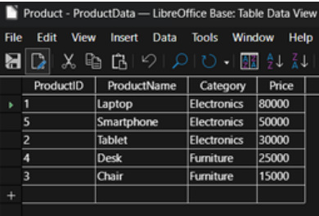
Fig. 1.1 Product table in Data View after sorting Price in descending order
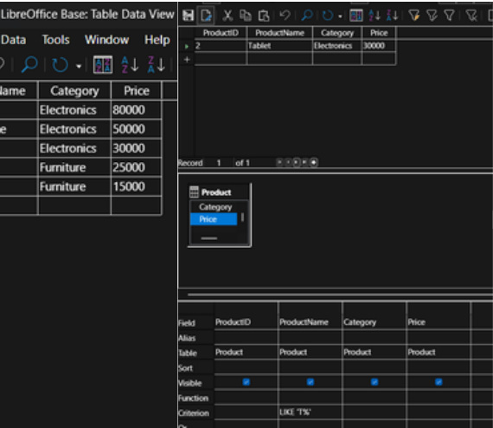
Fig. 1.2 Query design with the wildcard criteria under ProductName and the query result showing Tablet

02 | TASK 2 · LIBREOFFICE CALC  Compare Two Versions of a Financial Report

TASK
You have received two versions of a financial report from different teams. You need to identify discrepancies and reconcile the differences between the two sheets. How would you do this task in LibreOffice Calc?
The question gives no amounts, so the following sample data is used.
Comparison sheet
Item | Version 1 | Version 2 | Difference | Status
Sales | 50000 | 50000 | 0 | Matched
Expenses | 20000 | 22000 | 2000 | Discrepancy
Profit | 30000 | 28000 | -2000 | Discrepancy
STEPS
Step 1. Open LibreOffice Calc and enter the headings Item, Version 1, Version 2, Difference and Status in A1:E1.
Step 2. Make sure both versions use the same item names and the same row order, and that the periods, units and categories match.
Step 3. Enter the items in A2:A4, the Version 1 amounts in B2:B4 and the Version 2 amounts in C2:C4. If the versions sit on separate sheets, link them with cell references.
Step 4. In D2 enter =C2-B2 and fill the formula down to D4.
Step 5. In E2 enter =IF(D2=0;"Matched";"Discrepancy") and fill it down (some locales use commas instead of semicolons).
Step 6. Apply conditional formatting to the Difference column to highlight non-zero values.
Step 7. Compare every flagged item with the source reports and ask the relevant team to verify it. Record approved corrections and reasons in a Notes column.
Step 8. Save the workbook with all original values preserved and a clear reconciliation summary.
RESULT
A difference of 0 means the two versions agree. A positive difference means Version 2 is higher; a negative difference means Version 1 is higher. Sales matches, while Expenses (+2,000) and Profit (−2,000) are marked Discrepancy. The two differences are linked, because Profit = Sales − Expenses: Version 2 records ₹2,000 more expenses, so its profit is ₹2,000 lower. Verifying the Expenses figure therefore resolves both flags.
SCREENSHOTS
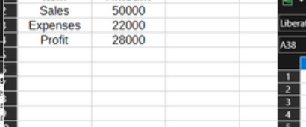
Fig. 2.1 Report values in the sheet: Sales 50000, Expenses 22000 and Profit 28000
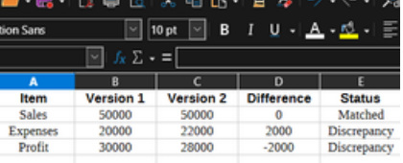
Fig. 2.2 Comparison sheet showing Version 1, Version 2, Difference and Status
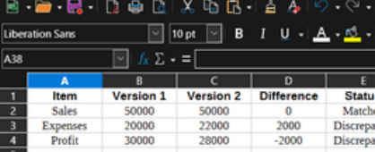
Fig. 2.3 Comparison sheet with row numbers and cell references visible

03 | TASK 3 · LIBREOFFICE BASE  Create a Table Using Design View

TASK
Create the following table using Design View:
• Sort the records by Place in descending order.
• Set Roll No. as the primary key.
• Delete record A002.
• Add another record.
Student records
Roll No. | Name | Date of Birth | Phone No. | Place
A001 | Manan Gupta | 12/09/1987 | 2354667667 | Delhi
A002 | Ryansh Sharma | 09/05/1986 | 3435555555 | Chhattisgarh
A003 | Rahul John | 02/05/1990 | 6565544324 | Mumbai
STEPS
Step 1. Open LibreOffice Base and choose Tables → Create Table in Design View.
Step 2. Create fields Roll No. (Text), Name (Text), Date of Birth (Date), Phone No. (Text) and Place (Text). Text is suitable for phone numbers because they are identifiers and may contain leading zeroes.
Step 3. Right-click the row selector for Roll No. and choose Primary Key.
Step 4. Save the table as StudentRecords. Open it in Data View and enter the three records exactly as shown in the question.
Step 5. Click the Place column header and choose descending sort. Confirm that the records are ordered by Place from Z to A.
Step 6. Locate record A002 and delete that record only. Confirm the deletion if prompted.
Step 7. Move to the new-record row and enter A004, Kavya Mehta, 15/08/1989, 9876543210, Jaipur.
Step 8. Save the table and reopen it to verify the primary key, sort order and final records.
RESULT
Roll No. is the primary key, so every record has a unique value. After deleting A002, records A001 and A003 remain along with the new record A004 (Kavya Mehta, Jaipur).
SCREENSHOTS
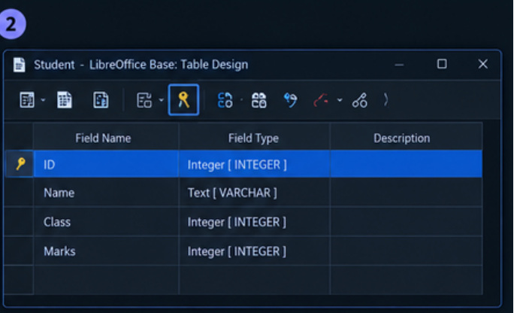
Fig. 3.1 Design View showing the table fields and primary key
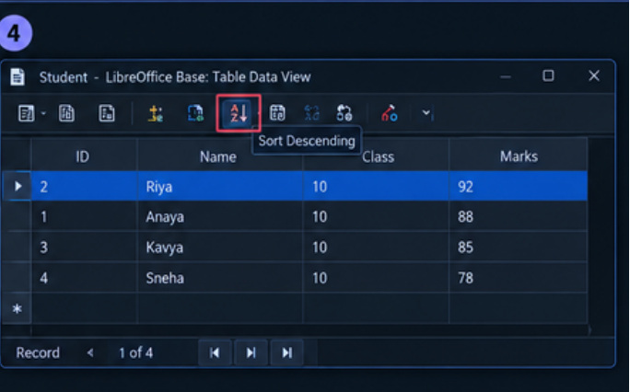
Fig. 3.2 Data View showing the Sort Descending option being used
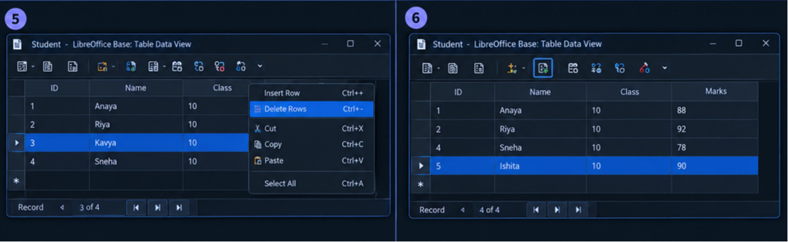
Fig. 3.3 Data View showing a record being deleted and a new record added

04 | TASK 4 · LIBREOFFICE BASE  School Database Relationships and Query

TASK
You are managing a school database that includes two main tables: Students and Classes.
• Set up a relationship between the Students table and the Classes table.
• Write a query to list all students along with the class they are in and the teacher of that class.
Students table
StudentID | StudentName | DateOfBirth | ClassID
1 | Priya Sharma | 2005-03-15 | 101
2 | Rahul Kapoor | 2004-07-22 | 102
3 | Meena Patel | 2005-11-10 | 101
4 | Aisha Khan | 2004-02-25 | 103
5 | Dev Rai | 2005-05-30 | 102
Classes table
ClassID | ClassName | TeacherName
101 | Mathematics | Mr. Prakash
102 | Science | Ms. Yashika
103 | History | Mrs. Seema
STEPS
Step 1. Create a database and make a Students table with StudentID as the primary key. Add StudentName, DateOfBirth and ClassID fields with suitable data types.
Step 2. Create a Classes table with ClassID as the primary key, plus ClassName and TeacherName. Enter the supplied data exactly.
Step 3. Open Tools → Relationships. Add Students and Classes to the relationship window.
Step 4. Drag Classes.ClassID onto Students.ClassID to create a one-to-many relationship. Enable referential integrity if the data types and existing values allow it.
Step 5. Create a query in Design View and add both tables.
Step 6. Add StudentName from Students, ClassName from Classes and TeacherName from Classes to the query grid.
Step 7. Check that Students.ClassID is joined to Classes.ClassID. Run the query and verify all five students appear.
Step 8. Save the query as StudentClassTeacherQuery.
RESULT
The query lists each student with the matching class and teacher: Priya Sharma — Mathematics — Mr. Prakash; Rahul Kapoor — Science — Ms. Yashika; Meena Patel — Mathematics — Mr. Prakash; Aisha Khan — History — Mrs. Seema; Dev Rai — Science — Ms. Yashika.
SCREENSHOTS
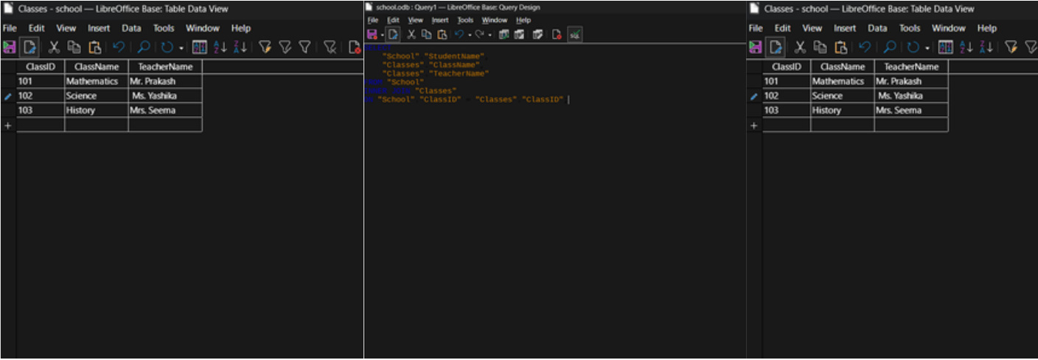
Fig. 4.1 Students and Classes tables showing their fields and records
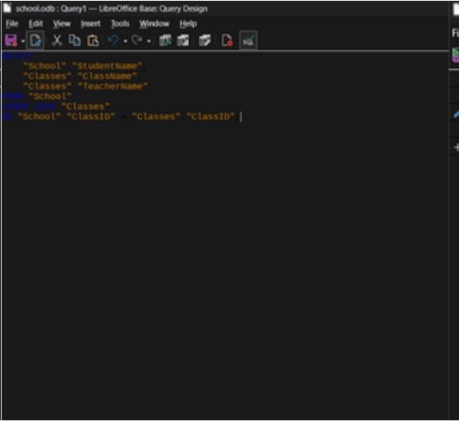
Fig. 4.2 Query design showing the class and teacher fields
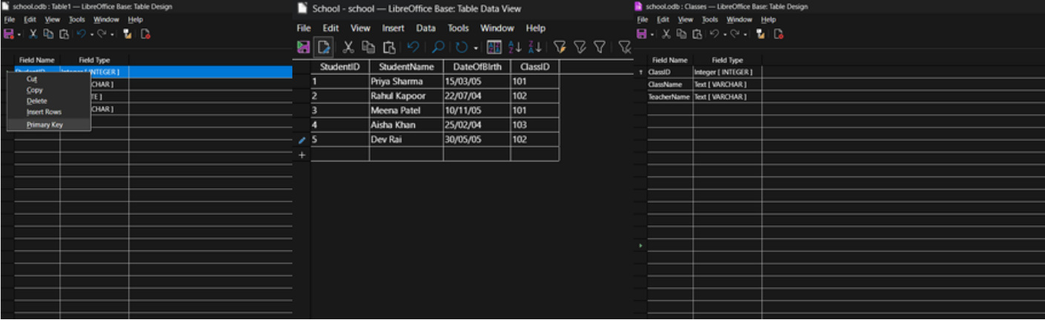
Fig. 4.3 Classes table and query-related database view

05 | TASK 5 · LIBREOFFICE CALC  Spreadsheet Average and Optimization

TASK
Consider the following spreadsheet:
• Calculate the average units sold in cell B8.
• Maximize the average number of units sold to 95.
• Use the optimization constraints given below.
Spreadsheet
Row | A | B
1 | Product | Units Sold
2 | A | 69
3 | B | 73
4 | C | 88
5 | D | 86
8 | Average Unit Sold
Optimization constraints
Cell | Constraint
B2 | ≤ 88
B3 | ≥ 82
B4 | ≤ 90
B5 | ≥ 60
STEPS
Step 1. Enter the product names in A2:A5 and the units sold in B2:B5. Keep the supplied starting values 69, 73, 88 and 86.
Step 2. Click B8 and enter =AVERAGE(B2:B5). Press Enter. The starting average is 79.
Step 3. Open Tools → Solver. Set the Target cell to $B$8.
Step 4. Set the cells to change (By changing cells) to $B$2:$B$5.
Step 5. Add the limiting conditions: B2 <= 88, B3 >= 82, B4 <= 90 and B5 >= 60.
Step 6. B3 and B5 have no upper limit, so a plain Maximum would never stop at 95. Select Value of and enter 95, so that Solver sets the average to exactly 95.
Step 7. Click Solve. In the Solver Results box choose Keep Result and click OK.
Step 8. Check that B8 still contains =AVERAGE(B2:B5) and that all four conditions still hold. Save the sheet.
RESULT
The starting average is 79. Solver then finds values whose average is 95 (total 380) while B2 ≤ 88, B3 ≥ 82, B4 ≤ 90 and B5 ≥ 60 all hold. One valid solution is B2 = 88, B3 = 100, B4 = 90 and B5 = 102.
SCREENSHOTS
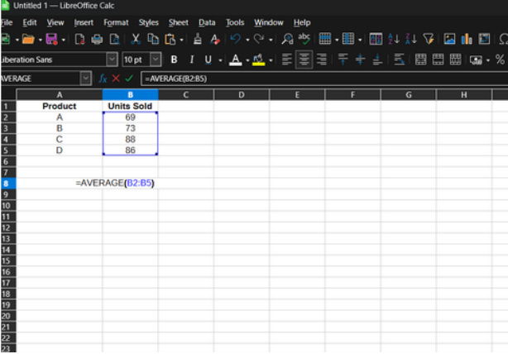
Fig. 5.1 Sheet with the four starting values and the average formula in B8
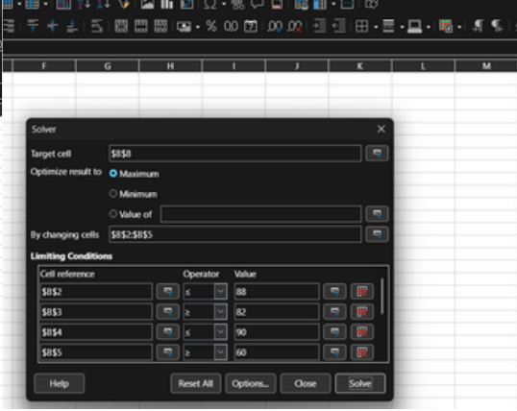
Fig. 5.2 Solver dialog with target $B$8, variable cells $B$2:$B$5 and the four constraints
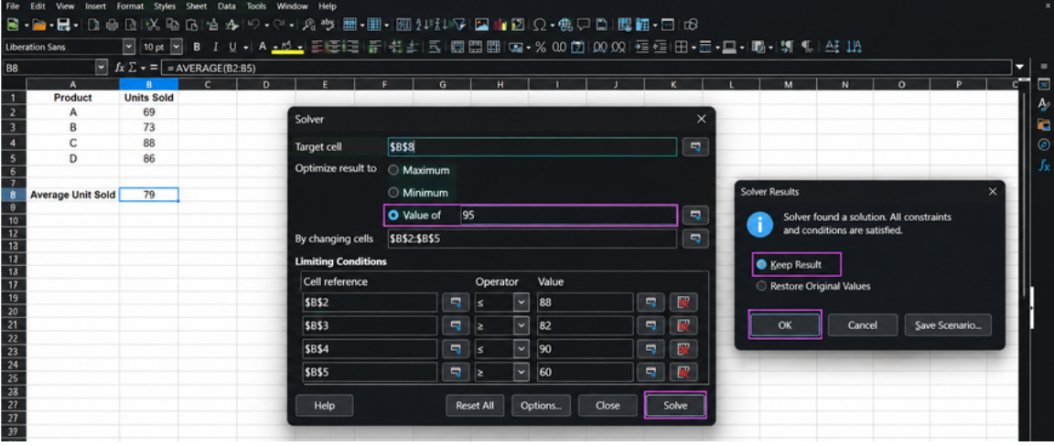
Fig. 5.3 Solver set to Value of 95, with the Solver Results box confirming a solution

06 | TASK 6 · LIBREOFFICE WRITER  Create a Bank Cash-Withdrawal Slip Template

TASK
Create a pro forma for a bank cash-withdrawal slip and add it to the Templates section.
STEPS
Step 1. Open Writer and create a new document. Type a centred heading such as BANK CASH WITHDRAWAL SLIP.
Step 2. Insert a table with fields for date, account holder name, account number, branch, amount in figures, amount in words, signature of account holder and authorised signature. Leave blank spaces for later use.
Step 3. Adjust table column widths, borders and spacing so the form fits on one page. Add a small bank name/logo placeholder only if permitted.
Step 4. Choose File → Templates → Save as Template. Name it Cash Withdrawal Slip and save it under My Templates.
RESULT
The bank cash-withdrawal slip is saved as a reusable template under My Templates.
SCREENSHOTS
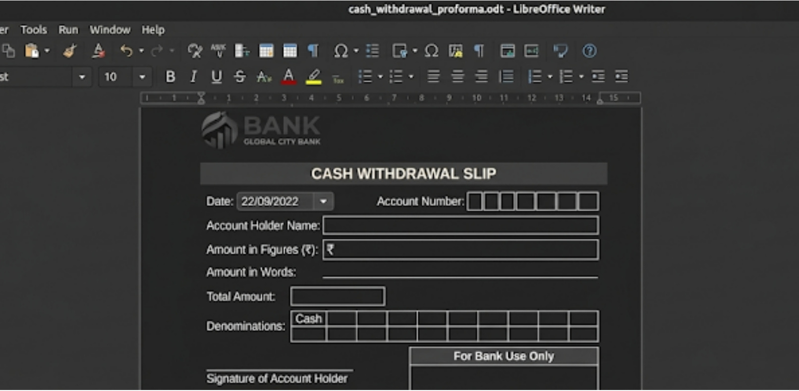
Fig. 6.1 Finished one-page withdrawal slip with the heading and all fields visible

07 | TASK 7 · LIBREOFFICE WRITER  Solar System Project Report

TASK
You are working on a project report about the solar system for your science class.
• Insert an image of the solar system, a constellation, and a spacecraft.
• Resize the solar system image to fit half of the page width.
• Crop the constellation image to remove the unnecessary background.
• Align the solar system image to the center of the page.
• Place the spacecraft image in the top-right corner of the page, with text wrapping around it.
STEPS
Step 1. Open Writer, create a project report and add the heading “The Solar System”.
Step 2. Insert suitable images of the solar system, a constellation and a spacecraft using Insert → Image.
Step 3. Keep the solar-system image’s proportions, resize it to half of the usable page width, and align it to the centre.
Step 4. Use the Crop controls on the constellation image to remove unnecessary background while keeping the constellation visible.
Step 5. Anchor the spacecraft image to a paragraph, place it in the top-right corner, and enable text wrapping around it. Review and save the report.
RESULT
The report contains all three images. The solar-system image is centred and sized to half the page width, the constellation background is cropped, and the spacecraft sits in the upper-right with text wrapping around it.
SCREENSHOTS
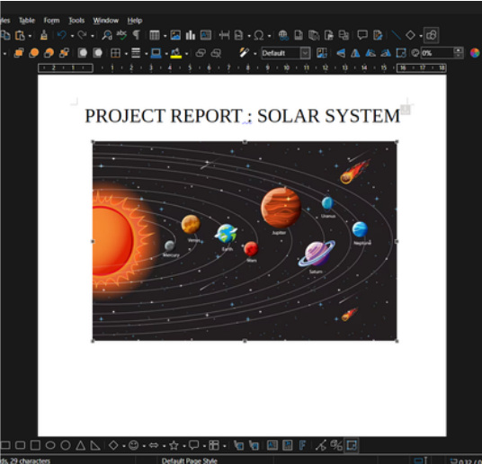
Fig. 7.1 Solar-system image centred and resized to half the page width

08 | TASK 8 · LIBREOFFICE WRITER  Conservation of Water: Paragraph and Picture

TASK
Write a paragraph on “Conservation of Water” and add a related picture. Resize the image to width 3.77 and height 3.99 (units are not specified in the source question). Crop the picture using scaling parameters of 50% width and 50% height.
STEPS
Step 1. Open Writer and type the heading “Conservation of Water”. Apply a clear heading style.
Step 2. Write a paragraph explaining why water is important and how people can reduce waste, repair leaks, reuse water where safe, harvest rainwater and protect groundwater.
Step 3. Choose Insert → Image and select a relevant water-conservation picture.
Step 4. Right-click the picture and open Properties → Type. Untick Keep ratio and enter width 3.77 and height 3.99 (inches).
Step 5. Open the Crop settings. Apply 50% scaling for width and 50% scaling for height as requested. Preview the crop to ensure the main subject remains visible.
Step 6. Set the image alignment and text wrapping so the paragraph and picture fit neatly on the page.
Step 7. Save the file and check the print preview for clipping or overflow.
RESULT
Paragraph used: “Water is important for people, animals and plants. We can save water by turning off taps, repairing leaks, collecting rainwater and using only the water we need. We should also keep rivers and lakes clean and protect groundwater for future generations.” The picture is sized 3.77 × 3.99 inches and cropped with 50% width and 50% height scaling.
SCREENSHOTS
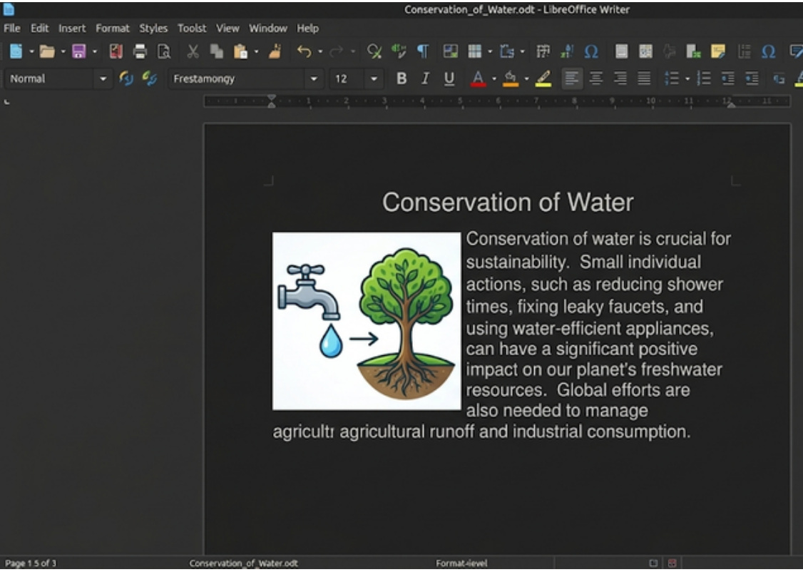
Fig. 8.1 Heading, paragraph and picture entered in Writer
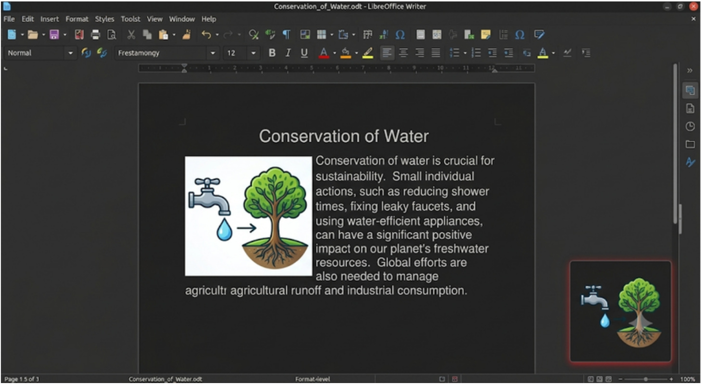
Fig. 8.2 Finished page with the paragraph and the resized, cropped image

09 | TASK 9 · LIBREOFFICE WRITER  Create a Paragraph Style Named “My list”

TASK
Create a new paragraph style with Bookman Old Style font, blue font colour, red text highlight, 18-point size and bold text. Save the style as My list.
Style settings
Setting | Value
Style name | My list
Font | Bookman Old Style
Font style | Bold
Font size | 18 pt
Font colour | Blue
Text highlight | Red
STEPS
Step 1. Open Writer and press F11 to open the Styles sidebar.
Step 2. Select Paragraph Styles. Right-click in the list and choose New.
Step 3. On the General tab, enter the style name My list.
Step 4. On the Font tab, choose Bookman Old Style, Bold, and 18 pt.
Step 5. On the Font Effects tab, choose blue as the font colour. Set the text highlight/background to red in the relevant highlighting or character-background control available in your LibreOffice version.
Step 6. Click OK to save the style.
Step 7. Type the sample text “Keep your work neat and organised.”, select the paragraph and double-click My list in the Styles sidebar.
Step 8. Check that the font, size, bold formatting, blue font colour and red highlight are applied. Save the document.
RESULT
The new paragraph style is saved as My list with Bookman Old Style, bold 18-point text, blue font and red highlighting. In some LibreOffice versions, text highlighting is set separately from font colour.
SCREENSHOTS
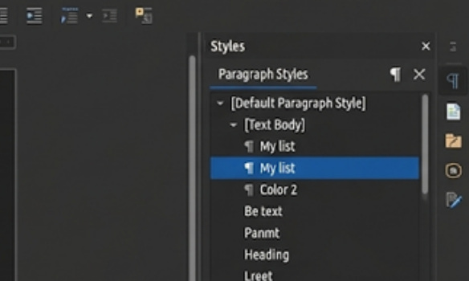
Fig. 9.1 New Paragraph Style dialog showing the name My list
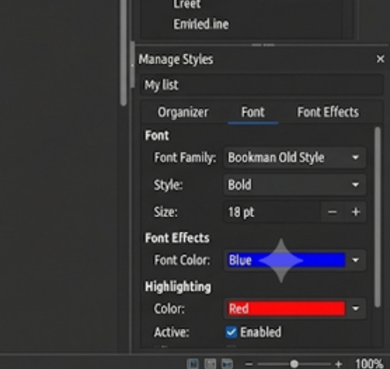
Fig. 9.2 Style properties showing Bookman Old Style, Bold, 18 pt, blue font and red highlight settings
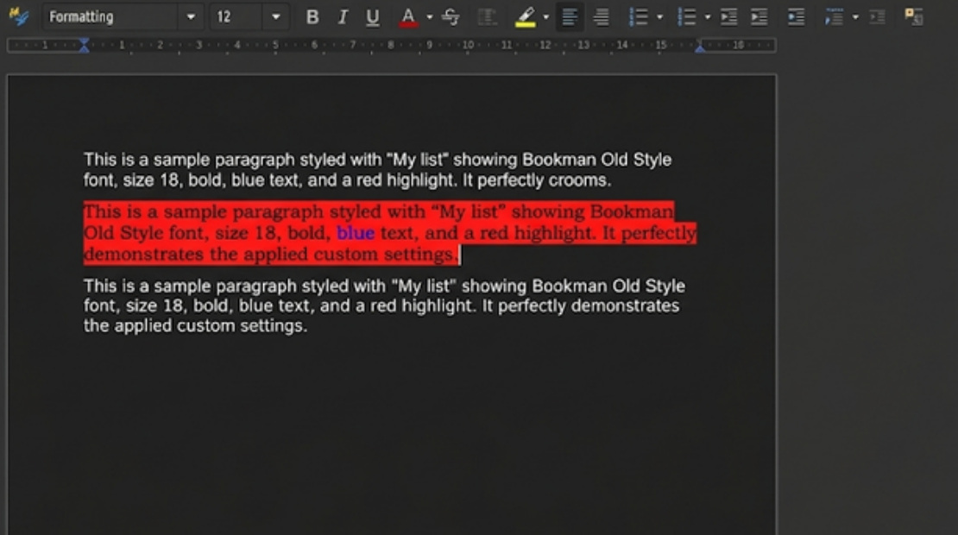
Fig. 9.3 Sample sentence with the saved style visibly applied

10 | TASK 10 · LIBREOFFICE CALC  Subtotal Marks by Subject

TASK
Mr. Laksh is preparing a list for a class of 30 students. He enters marks for five different subjects. Group the students by subject and calculate the subtotals for each subject.
The question gives no marks, so the following sample data (30 students, five subjects) is used.
STEPS
Step 1. For student marks, create columns Student Name, Subject and Marks. Enter all 30 student records and ensure every subject is spelled consistently.
Step 2. Sort the data by Subject in ascending order using Data → Sort. This is important because Calc Subtotals works on grouped, sorted records.
Step 3. Choose Data → Subtotals. Under Group by, select Subject; under Calculate subtotals for, select Marks; choose Sum. Click OK.
Step 4. Check that a subtotal row appears under every subject and that a Grand Total appears at the end. Use the outline buttons on the left to collapse or expand the student rows.
RESULT
Subtotals: English 483, Hindi 488, Mathematics 507, Science 501, Social Science 485. Grand total: 2464.
SCREENSHOTS
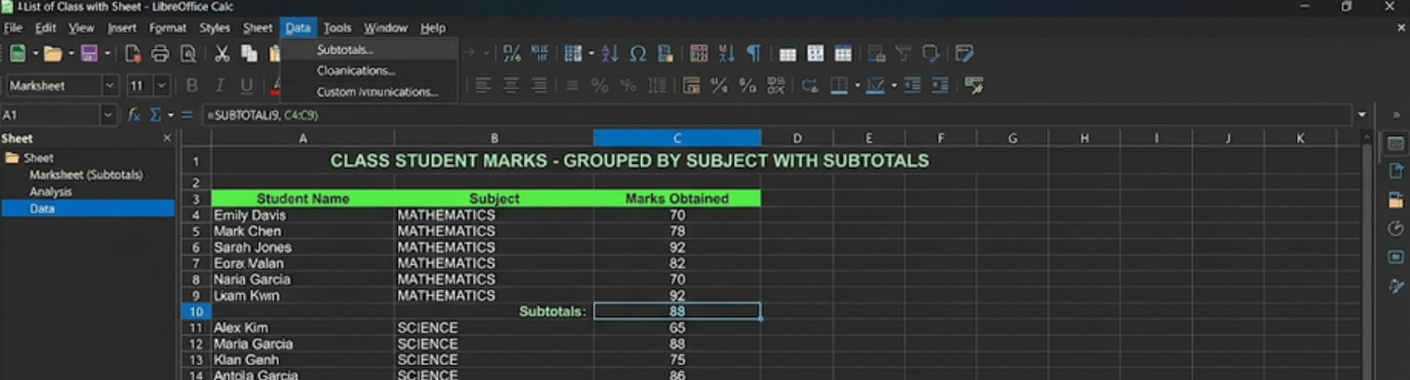
Fig. 10.1 Spreadsheet showing student marks grouped by subject
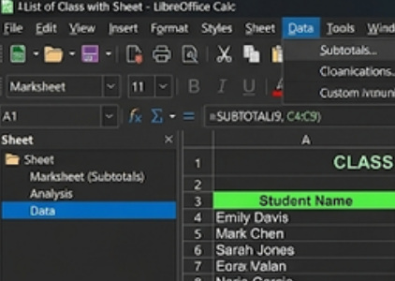
Fig. 10.2 Data menu with the Subtotals command visible
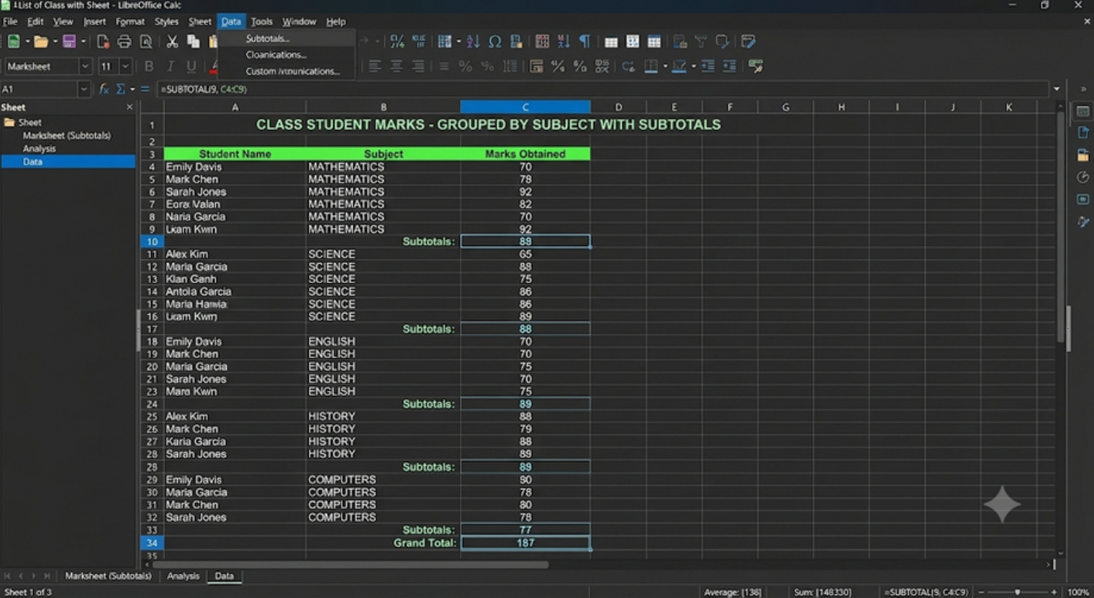
Fig. 10.3 Finished grouped sheet with each subject’s subtotal rows visible

11 | TASK 11 · LIBREOFFICE WRITER  Annual Report: Table of Contents

TASK
You are compiling the annual report for your school, which includes multiple chapters. Create a table of contents with main topics and subtopics. Apply character styles so main topics are bold and subtopics italic. Update the TOC as new sections are added to the report.
STEPS
Step 1. Open the annual report in Writer. Apply Heading 1 to main chapter titles and Heading 2 to subtopics.
Step 2. Place the cursor where the contents should appear and choose Insert → Table of Contents and Index → Table of Contents, Index or Bibliography.
Step 3. Edit the TOC entry styles so main-topic entries appear in bold and subtopic entries appear in italics.
Step 4. Add a new heading or subtopic to the report, then right-click the TOC and choose Update Index/Table of Contents.
Step 5. Check the hierarchy and page numbers, then save the report.
RESULT
The report includes an automatically generated table of contents with bold main topics and italic subtopics. Updating the TOC refreshes its entries and page numbers when the report changes.
SCREENSHOTS

Fig. 11.1 Annual report with its cover, table of contents and chapter pages

Fig. 11.2 Report pages with Heading 1 chapters and Heading 2 subtopics

Fig. 11.3 Closer view of chapters 3 to 5 of the annual report

12 | TASK 12 · LIBREOFFICE CALC  Goal Seek: Monthly Gadget Revenue

TASK
Vishal manages a store that sells gadgets A, B and C at ₹100, ₹150 and ₹200 per unit. He expects to sell 200 units of A and 150 units of B. Determine how many units of C are needed to reach total revenue of ₹50,000 using Goal Seek.
Gadget prices
Gadget | Selling price per unit
A | ₹100
B | ₹150
C | ₹200
STEPS
Step 1. Type GADGET DATA in A1 and the headings Gadget Name, Price (₹), Quantity Sold and Revenue (₹) in row 2. Enter A: 100 and 200 units; B: 150 and 150 units; C: 200, and leave its quantity as a starting guess.
Step 2. Calculate revenue for each gadget in D3:D5 using =B3*C3 and fill the formula down.
Step 3. In D7 calculate TOTAL MONTHLY REVENUE with =SUM(D3:D5).
Step 4. Choose Tools → Goal Seek. Set the Formula cell to $D$7, the Target value to 50000 and the Variable cell (By changing cell) to $C$5, the quantity of Gadget C.
Step 5. Click OK and accept the result if Goal Seek finds a solution. Format the revenue cells as currency.
Step 6. Verify the result manually and save the workbook.
RESULT
Gadget A brings in ₹20,000 and Gadget B brings in ₹22,500, for a total of ₹42,500. The remaining amount is ₹7,500. At ₹200 per unit, Gadget C needs to sell 37.5 units. If only whole units are allowed, 37 units gives ₹49,900 and 38 units gives ₹50,100.
SCREENSHOTS
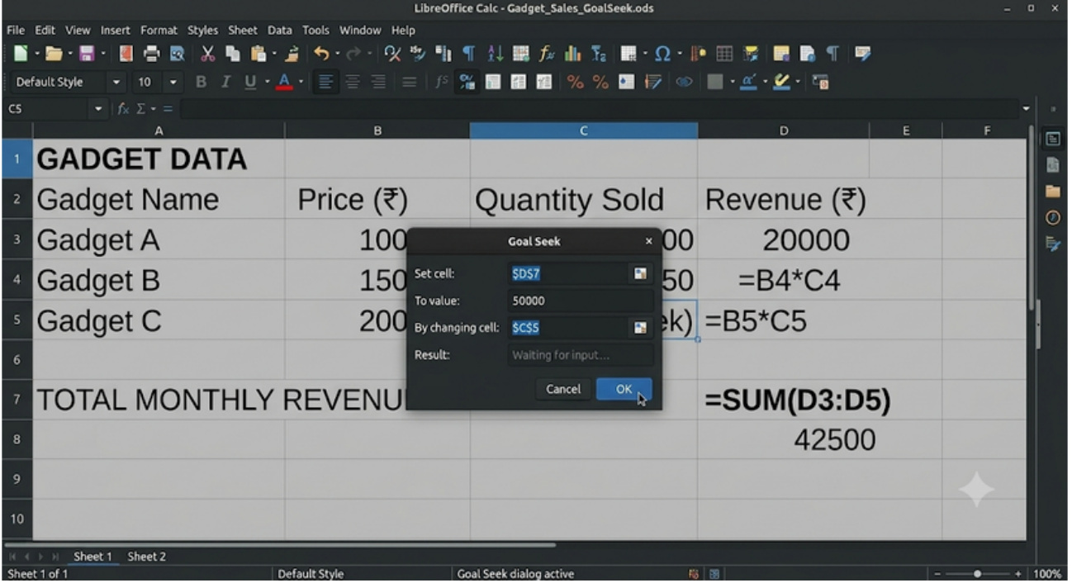
Fig. 12.1 Gadget sheet with the Goal Seek dialog open
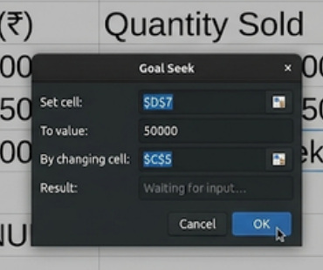
Fig. 12.2 Goal Seek dialog with formula cell $D$7, target value 50000 and variable cell $C$5

13 | TASK 13 · LIBREOFFICE CALC  Add Hyperlinks to a Book Inventory

TASK
The school librarian wants to include a hyperlink in her book inventory spreadsheet that directs students to the school library’s online catalogue. Help her add the hyperlink.
Book inventory
Book Title | Online Catalog Link
To Kill a Mockingbird | [Link to Catalog]
1984 | [Link to Catalog]
The Great Gatsby | [Link to Catalog]
STEPS
Step 1. Open Calc and create the Book Title and Online Catalog Link columns (the inventory sheet can also hold other columns such as Book ID, Author and ISBN). Enter the three titles exactly as supplied.
Step 2. Ask the librarian for the official school library catalogue URL. The question does not provide the actual URL, so do not invent one.
Step 3. Select the link cell for the first title and press Ctrl+K, or choose Insert → Hyperlink.
Step 4. Choose Internet or Web, paste the official catalogue URL and set the display text to Link to Catalog. Click Apply/OK.
Step 5. Repeat for each row. If the same catalogue page is used for all titles, the same URL can be used; otherwise use the correct title-specific catalogue links supplied by the librarian.
Step 6. Test each link by Ctrl-clicking or using the hyperlink action, depending on the Calc settings. Save the spreadsheet.
RESULT
The sheet shows all three titles, each with a clickable link labelled “Link to Catalog” that opens the school library’s online catalogue.
SCREENSHOTS
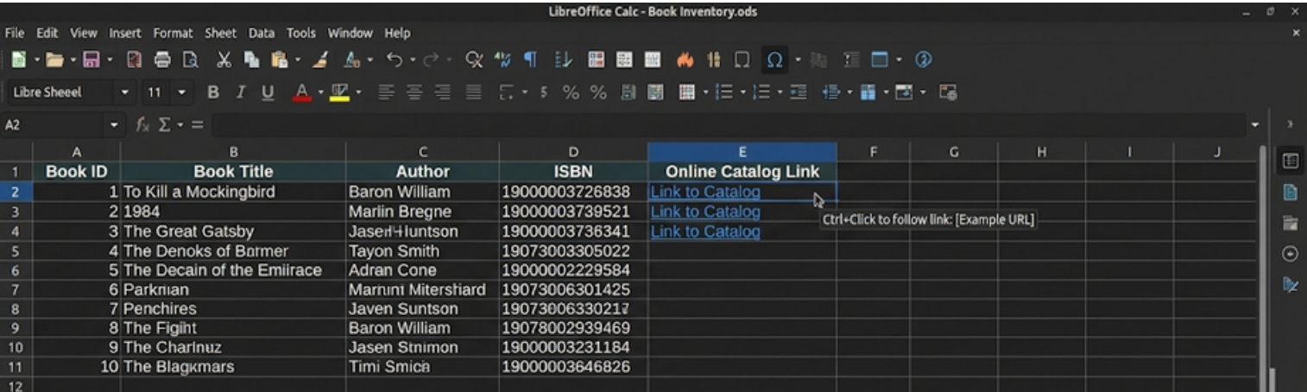
Fig. 13.1 Book inventory sheet with the Link to Catalog entries and the Ctrl+Click tooltip
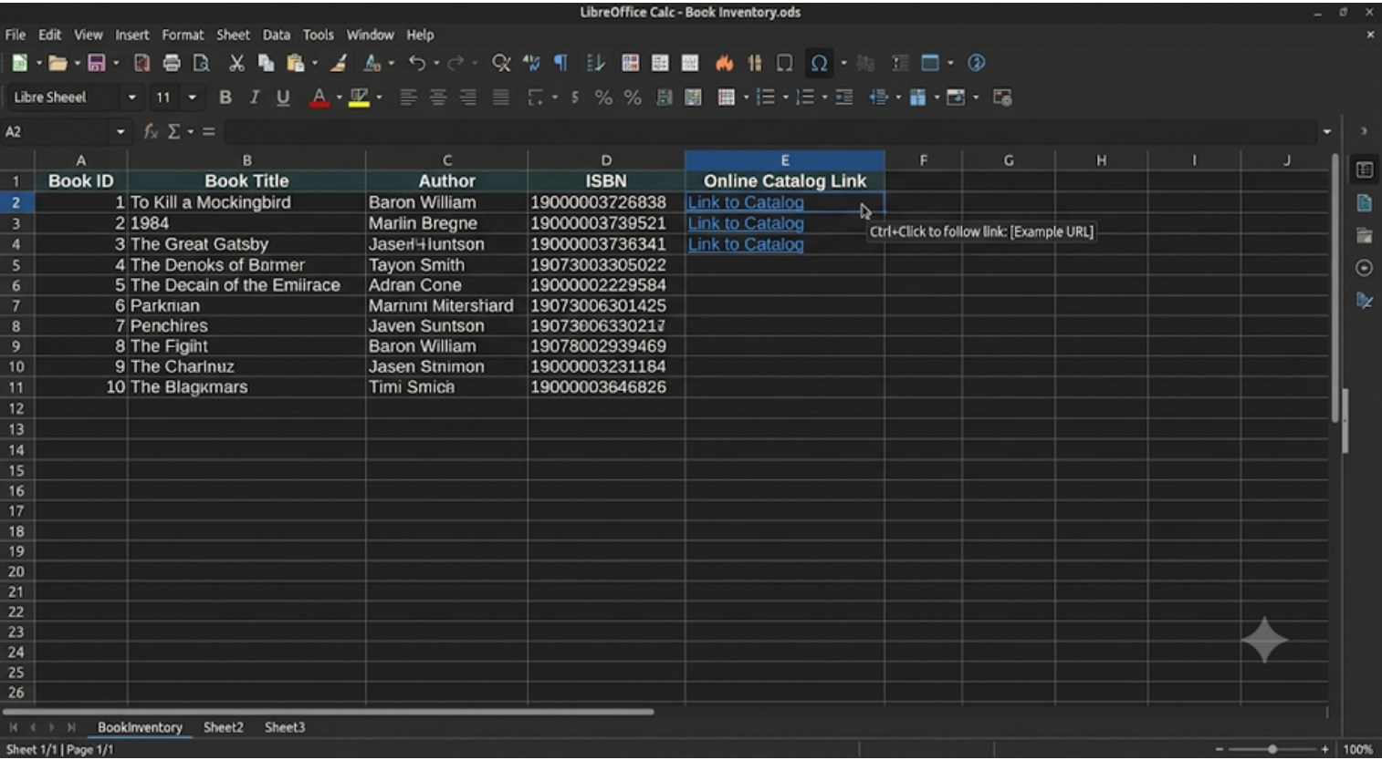
Fig. 13.2 Finished sheet with clickable link text visible for the books

14 | TASK 14 · LIBREOFFICE CALC  Consolidate Data from Two Sheets

TASK
Consolidate the data from the two sheets below into a third sheet in LibreOffice Calc.
Sheet 1
Name | June Pocket Money
Amit | 1200
Sumit | 1000
Naina | 1500
Suman | 1300
Kamal | 1400
Sheet 2
Name | July Pocket Money
Amit | 900
Sumit | 1100
Naina | 1300
Suman | 1200
Kamal | 1250
STEPS
Step 1. Create three sheets named Sheet1, Sheet2 and Consolidated.
Step 2. On Sheet1, enter the Name and June Pocket Money columns exactly as shown. On Sheet2, enter Name and July Pocket Money.
Step 3. On Consolidated, create columns Name, June Pocket Money, July Pocket Money and Total. Enter each name once in the same row order.
Step 4. Link the June values from Sheet1 and July values from Sheet2 using cell references, for example =Sheet1.B2 and =Sheet2.B2. Use the exact sheet names and cell locations in your workbook.
Step 5. In the Total column, enter =SUM(B2:C2) and fill the formula down for all five names.
Step 6. Check that every name matches between the two source sheets and that no row has shifted. Format amounts as currency if required.
Step 7. Save the workbook.
RESULT
The totals are Amit ₹2,100, Sumit ₹2,100, Naina ₹2,800, Suman ₹2,500 and Kamal ₹2,650. The June total is ₹6,400 and the July total is ₹5,750, giving a combined total of ₹12,150.
SCREENSHOTS
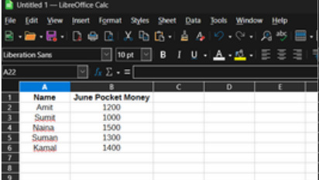
Fig. 14.1 Sheet1 with the June data
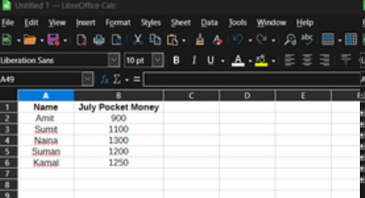
Fig. 14.2 Sheet2 with the July data
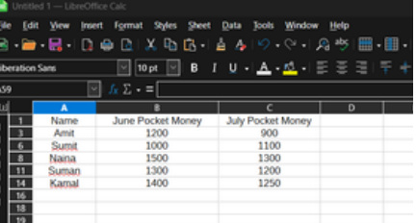
Fig. 14.3 Consolidated sheet showing June and July values for all five names

15 | TASK 15 · LIBREOFFICE BASE  Create and Modify the Salesman Table

TASK
Create a table named Salesman with the following structure:
The question gives no records, so the following 15 fictional sample records are used. Gender fills with Male by default. The table is then modified as follows: add a field Gender with the default value Male; delete the records with SM_ID 3 and 6; change Address1 and Address2 to Text (50); and sort SM_Name in ascending and then descending order.
Salesman fields
Field Name | Data Type
SM_ID | Number (NUMERIC)
SM_Name | Text (35 Characters)
Address1 | Text (40 Characters)
Address2 | Text (40 Characters)
City | Text (15 Characters)
State | Text (15 Characters)
PinCode | Number
Sell_Amt | Number
Comm | Number
Phone | Number
Sample records
SM_ID | SM_Name | Address1 | Address2 | City | State | PinCode | Sell_Amt | Comm | Phone
1 | Arjun Sharma | 12 Green Park | Block A | Delhi | Delhi | 110016 | 45000 | 5 | 9876501001
2 | Neha Verma | 23 Model Town | Block B | Delhi | Delhi | 110009 | 52000 | 6 | 9876501002
3 | Rohan Gupta | 14 Sector 14 | Near Market | Gurugram | Haryana | 122001 | 61000 | 7 | 9876501003
4 | Priya Singh | 8 Civil Lines | Lane 2 | Jaipur | Rajasthan | 302006 | 47000 | 5 | 9876501004
5 | Aman Khan | 19 Ring Road | Floor 1 | Lucknow | Uttar Pradesh | 226001 | 39000 | 4 | 9876501005
6 | Kavya Patel | 31 MG Road | Flat 2 | Ahmedabad | Gujarat | 380001 | 56000 | 6 | 9876501006
7 | Dev Mehta | 6 Lake View | Main Road | Mumbai | Maharashtra | 400001 | 72000 | 8 | 9876501007
8 | Sana Ali | 44 Park Street | Block C | Kolkata | West Bengal | 700016 | 43000 | 5 | 9876501008
9 | Rahul Das | 17 Station Road | Near Post Office | Patna | Bihar | 800001 | 41000 | 4 | 9876501009
10 | Anaya Rao | 29 Beach Road | Unit 4 | Chennai | Tamil Nadu | 600001 | 65000 | 7 | 9876501010
11 | Kabir Joshi | 12 Lake Road | Block A | Pune | Maharashtra | 411001 | 58500 | 6 | 9876501011
12 | Meera Nair | 7 Hill View | Near School | Kochi | Kerala | 682001 | 51000 | 6 | 9876501012
13 | Ishaan Roy | 15 Market Road | Unit 8 | Bhopal | Madhya Pradesh | 462001 | 48000 | 5 | 9876501013
14 | Diya Sethi | 22 Central Avenue | Block D | Chandigarh | Chandigarh | 160017 | 63000 | 7 | 9876501014
15 | Yash Kapoor | 9 Rose Garden | Floor 3 | Dehradun | Uttarakhand | 248001 | 46000 | 5 | 9876501015
STEPS
Step 1. Open LibreOffice Base and choose Tables → Create Table in Design View.
Step 2. Create the fields as listed, with the given data types and lengths. Use BIGINT for Phone, as a 10-digit number is too large for INTEGER.
Step 3. Set SM_ID as the primary key if required by the database design, then save the table as Salesman.
Step 4. Open the table in Design View again and add a field named Gender. Set its default value to Male. Save the table.
Step 5. Open Salesman in Data View and enter the 15 sample records. Confirm that Gender fills with Male automatically.
Step 6. Delete the records with SM_ID 3 (Rohan Gupta) and SM_ID 6 (Kavya Patel), as instructed.
Step 7. Return to Design View. Change Address1 and Address2 from Text(40) to Text(50). Save the changes.
Step 8. Sort the SM_Name field in ascending order and inspect the result. Then sort it in descending order and inspect the result.
Step 9. Save and reopen the table to confirm the field widths, default Gender value, record count and sort behaviour.
RESULT
After the two deletions, 13 records remain. Address1 and Address2 are Text (50) and Gender defaults to Male. Sorted A–Z the list starts with Aman Khan; sorted Z–A it starts with Yash Kapoor.
SCREENSHOTS
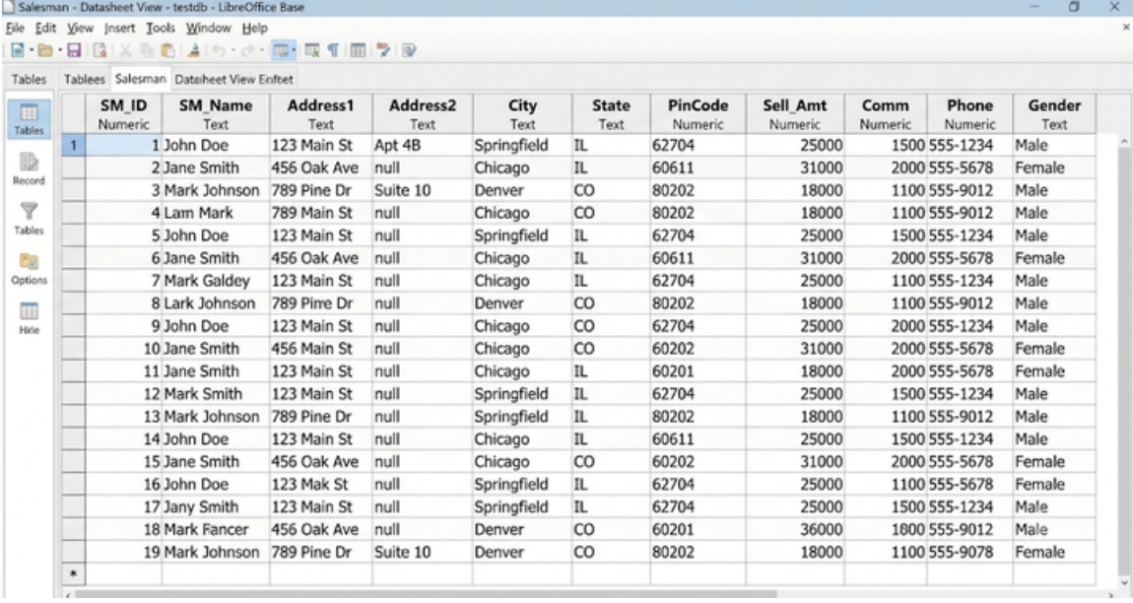
Fig. 15.1 Salesman table in Data View showing sample records and the Gender field

Conclusion

In this file, I practised using LibreOffice Writer, Calc and Base. In Writer, I created a bank cash-withdrawal slip template, prepared a solar-system report with carefully placed images, built a table of contents for an annual report, resized and cropped a picture, and saved a paragraph style.
In Calc, I used formulas, hyperlinks, subtotals, Goal Seek, Solver and financial reconciliation. I linked data from two sheets with cell references, used Goal Seek to find that Gadget C needs 37.5 units to reach ₹50,000, and used Solver to bring an average to 95 within the given limits. Grouping marks by subject helped me summarize data clearly.
In Base, I created tables, set primary keys, built a relationship between Students and Classes, ran a wildcard query to find products that start with T, and prepared reports. Modifying the Salesman table showed me why field sizes and default values matter.
I also learned to check source data, use clear field names, verify formulas and keep original records when reconciling differences. Where a question did not supply data, I used clearly labelled sample values.
These activities helped me become more confident with document formatting, spreadsheets and databases.
Hitesh Kumar
Class 10-D · Roll No. 10413

